Table of Contents
1. Introduction 1
2. Problem Statement 1
3. Objectives 2
4. Methodology 2
a. Requirement Identification 2
i. Study of existing system 2
ii. Literature Review 2
iii. Requirement Analysis 3
b. Feasibility Study 5
c. High Level Design of System 6
5. Gantt Chart 9
6. Expected Outcome 10
References 11

Introduction
The Career Guidance System is a website built to help students make smart career choices. It does this by looking at their school grades, what they're interested in, and the skills they already have. The system uses three main methods to give personalized suggestions: it recommends careers based on what students like and are good at, it predicts how likely they are to succeed in different jobs, and it finds other skills they can learn to become more employable. By bringing these parts together, the system offers a complete, data-driven way to plan a career. This makes it easier for students to find options that match their abilities and goals. Overall, this platform not only simplifies the often tricky process of choosing a career but also gives students useful advice and tips for developing new skills, all within an easy-to-use and interactive website.

Problem Statement
Many career guidance methods today give only general advice or depend on limited counseling sessions and scattered websites. They don’t fully understand each student’s unique interests, academic performance, background, and skills. Because of this, students often miss out on personalized career suggestions, lack insight into their chances of success in various professions, and don’t receive targeted recommendations on what new skills to learn or develop. Therefore, there is a growing need for a smart, simple, and comprehensive Career Guidance System that uses advanced technologies like AI and data analytics to provide personalized career advice, predict success probabilities, and suggest relevant skill-building paths—all within one easy-to-use, connected platform to help students make confident and informed career decisions.

Objectives
The objectives of career guidance system are :-
- To suggest suitable based on students' interests and marks.
- To predict how likely a student is to succeed in different careers.
- To recommend new skills for students to learn based on the skills they already have.
- To create a simple system that also generates a resume automatically using the student's information.

Methodology

Requirement Identification

Study of existing system
Most current career guidance tools give general advice but don’t focus on each student’s interests, marks, or skills. They usually don’t predict how well a student will do in a career or suggest new skills to learn. Also, very few systems can create resumes automatically from student details. Some popular tools like CareerOneStop and My Next Move help explore careers but lack personalized features. My system will combine career suggestions, success prediction, skill advice, and resume making all in one easy platform.

Literature Review
Career guidance systems play an important role in helping students choose suitable career paths by analyzing their interests, academic records, and skills. Many modern systems use rule-based filtering to provide clear and easy-to-understand career suggestions based on user inputs [1]. Prediction models like logistic regression are used to estimate the chances of success in different careers, giving students helpful insights for decision-making [2]. Association rule mining is also used to recommend new skills by finding common skill combinations that improve job readiness [3]. These systems often use web technologies such as PHP and MySQL to create interactive platforms that include login features, data management, and automatic resume generation, making the career guidance process easier and more personalized [4]. Recent research highlights that combining simple yet effective algorithms with user-friendly web applications improves career planning for students.

iii. Requirement Analysis
- Functional Requirement
Admin:
- Admin can manage career options (add, update, or delete careers).
- Admin can manage skill suggestions and update them as needed.
- Admin can view student profiles and their career recommendations.
- Admin can manage user accounts and handle system data.
User
- User can register and log in securely to the system.
- User can enter their interests, academic details, and skills.
- User can receive personalized career recommendations.
- User can view predicted success rates for different careers.
- User can get suggestions for new skills to learn.
- User can generate and download a resume based on their data.
- Non-Functional Requirement
- The system should be easy to use and accessible anytime from any device.
- The system should protect user data through secure login and validation.
- The system should be easy to maintain and update.
- The system should respond quickly to user requests without delays.
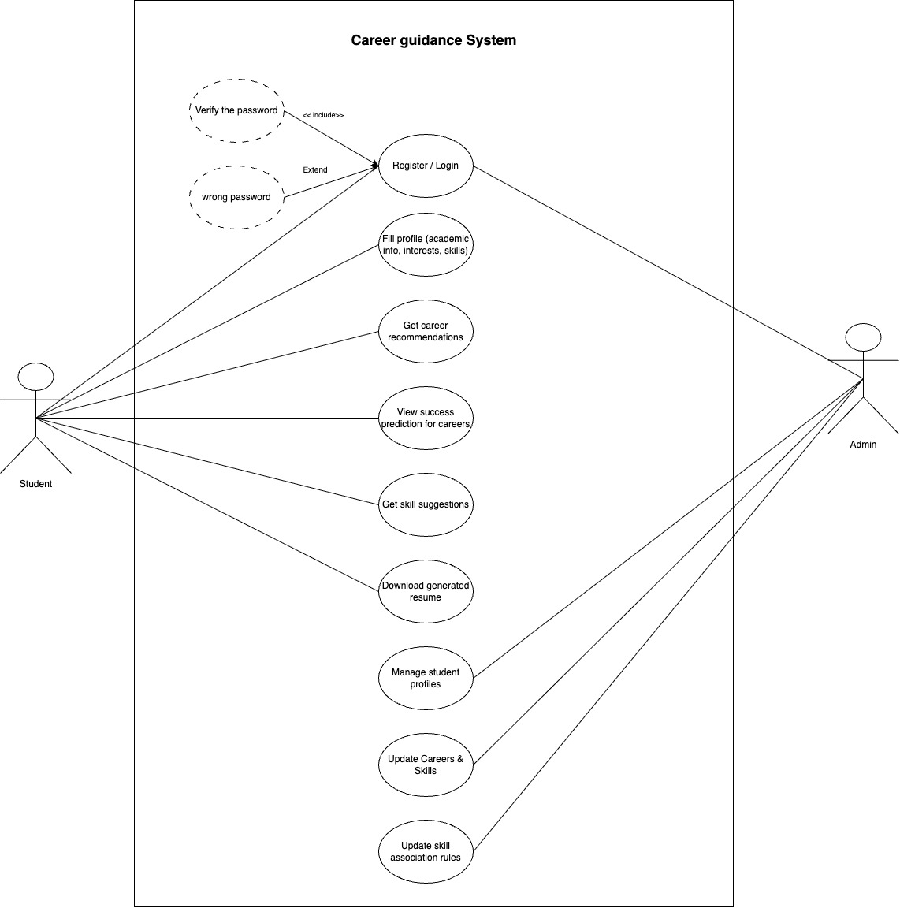
FIG : Usecase Diagram

Feasibility Study
- Technical
This study focuses on the hardware and software needed for the project. All the software tools and programming languages used such as HTML, CSS, JavaScript for the front end, and PHP and MySQL for the back end are free and easily available. The required hardware, like a computer with internet access, is also available. Therefore, the technical resources needed to develop this system are accessible and affordable. All the software tools and programming languages used such as HTML, CSS, JavaScript for the front end, and PHP and MySQL for the back end are free and easily available.
- Operational
The system is easy for students to use when entering their information and getting career guidance. It will improve user experience by giving quick, personalized career recommendations and resume creation. The system is simple to operate and requires minimal training, so students and admins can quickly learn to use it without difficulty.
- Economic
The project is cost-effective because it uses free software and existing hardware. It can save time and effort by automating career guidance and resume creation, reducing the need for manual counseling. This can improve student satisfaction and help educational institutes offer better services without high costs. The benefits, such as saving time and improving decision-making, outweigh the development costs.

High Level Design of System
i. Methodology used in Proposed System
The development of this career guidance system begins with system analysis, which helps understand what the system needs to do. During this phase, a data model is created to design the database that will store student and career information. Use case diagrams are used to clearly show how users (students and admins) will interact with the system and what functions the system must perform. For this project, the Waterfall Model is chosen as the development methodology because the requirements are clear and fixed from the start. The waterfall model is easy to follow, making the development process simple and organized. This approach helps build a user-friendly and easy-to-manage system that students and admins can use without difficulty.
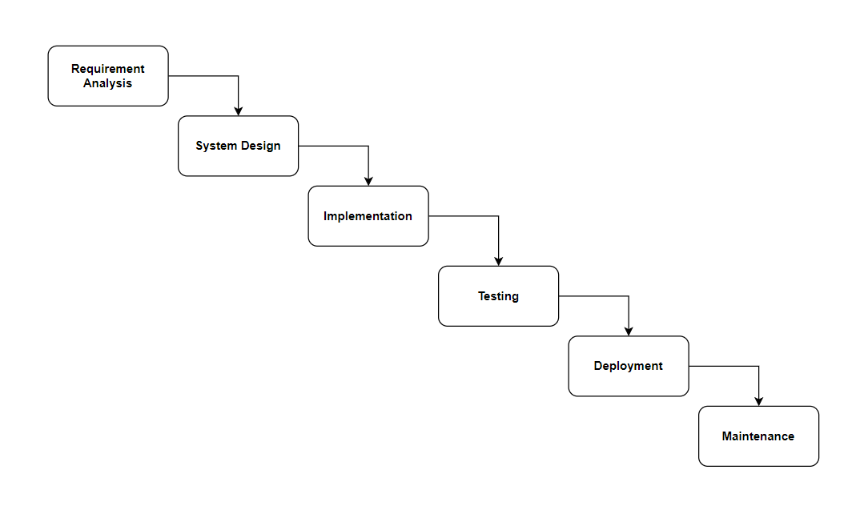
Fig no. 1: Waterfall development model
ii. Description of Algorithm
This system uses three main algorithms to provide career guidance:
- Rule-Based Filtering Algorithm
Rule-Based Filtering Algorithm for Career Recommendation: This algorithm uses simple rules based on the student’s interests and academic scores to suggest suitable careers. It checks the answers given by the student and matches them with predefined career options.
- Logistic Regression Algorithm
Logistic Regression Algorithm for Career Success Prediction: This algorithm predicts the likelihood of a student’s success in different career paths by analyzing their data. It gives a probability score that helps students understand which careers they may do well in.
- Association Rule Mining Algorithm
Association Rule Mining Algorithm for Skill Suggestion: This algorithm analyzes the skills the student already has and finds related skills that often appear together. It then suggests these new skills to help improve the student’s chances in their chosen career.

Gantt Chart
In my project’s Gantt chart, the planning phase is complete. Currently, I am working on the research and analysis phase. The upcoming phases include design, coding, testing, deployment, and documentation. Each of these phases is scheduled to start soon, following the completion of the previous steps, to ensure smooth progress and timely completion of the project.

Activity | Months | June |  |  |  | July |  |  |  |  | August |  |  |  |  | status
Activity | Weeks | 1 | 2 | 3 | 4 | 1 | 2 | 3 | 4 | 1 |  | 2 | 3 | 4
Project Planning |  |  |  |  |  |  |  |  |  |  |  |  |  |  | Done
Research Analysis |  |  |  |  |  |  |  |  |  |  |  |  |  |  | Done
Design |  |  |  |  |  |  |  |  |  |  |  |  |  |  | upcoming
Coding |  |  |  |  |  |  |  |  |  |  |  |  |  |  | upcoming
Testing |  |  |  |  |  |  |  |  |  |  |  |  |  |  | upcoming
Deployment |  |  |  |  |  |  |  |  |  |  |  |  |  |  | upcoming
Documentation |  |  |  |  |  |  |  |  |  |  |  |  |  |  | upcoming

Fig no. 3: Gantt Chart

Expected Outcome
Implementing the Career Guidance System will help students easily find suitable career options based on their interests and skills. It will reduce confusion and manual effort in career planning by providing automated, personalized recommendations. The system will also predict the chances of success in different careers, helping students make better decisions. Additionally, it will suggest new skills to learn, improving students’ readiness for the job market. The automatic resume generation feature will save time and help students create professional resumes quickly. Overall, the system will improve career planning efficiency and support students in building a successful future.

References
- S. Patel and R. Desai, "Rule-Based Career Recommendation System for Students Using Web Technologies," International Journal of Advanced Computer Science and Applications, vol. 11, no. 6, pp. 276-281, 2020.
- L. Chen and M. Wang, "Career Success Prediction Using Logistic Regression in Educational Systems," Journal of Educational Technology & Society, vol. 23, no. 3, pp. 45-53, 2020.
- A. Singh and P. Kumar, "Skill Suggestion Model Based on Association Rule Mining for Career Development," International Journal of Computer Applications, vol. 182, no. 38, pp. 12-18, 2021.
- R. Gupta and S. Sharma, "Web-Based Career Guidance System with Resume Generation," International Journal of Computer Science and Mobile Computing, vol. 10, no. 5, pp. 89-95, 2022.

